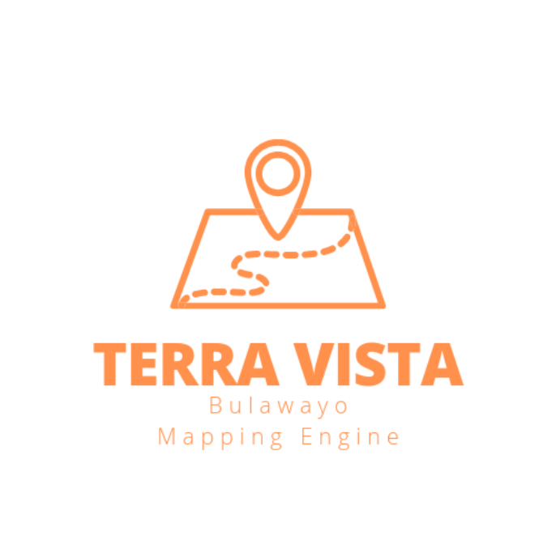
1. Introduction
Terra Vista meaning:
“Terra Vista” represents the essence of this mapping engine software as a powerful tool for exploring and visualizing Bulawayo and the world all over. “Terra” symbolizes the Earth, highlighting the software’s focus on geographical data, maps, and spatial information. It signifies a connection to the physical world, its landscapes, and the vast possibilities for exploration.
”Vista” evokes the idea of expansive and breathtaking views. It embodies the software’s ability to provide users with a panoramic and comprehensive perspective of geographical data. It emphasizes the software’s role in presenting maps, routes, and locations in a visually appealing and user-friendly manner.
Together, “Terra Vista” encapsulates the core functionalities and purpose of the mapping engine software. It conveys the software’s mission to enable users to navigate, explore, and gain valuable insights into the world around them through intuitive and visually captivating mapping capabilities.
The word “Terra” is derived from Latin, where it means “earth” or “land.” It is a commonly used term in various fields related to geography, geology, and earth sciences.
The word “Vista” is derived from the Latin word “videre,” which means “to see” or “to view.” It refers to a scenic or extensive view, often associated with a broad or panoramic perspective. Both “Terra” and “Vista” have been widely adopted and integrated into the English language, maintaining their original meanings from Latin.

2. Background of the app/ origins:
Terra Vista is a mapping and surveying engine that has been developed under Northerveil Incorporated (Private) Limited in partnership with Mthoe Saps Construction Technologies. It is developed in order to help professionals in the real estate, construction, engineering and Environmental Management sector. This engine is made and optimized for Desktop, Laptop, Android and Apple Devices. The Engine comes in two forms that is PC version and Mobile app version. Due to the robust powers of the engine, the mobile version has been designed but it is still currently undergoing optimization since mobile devices do not have the same power as computers thus the mobile version will be released as soon as it is done being optimized. The engine is designed and optimized to wok on both pc and mobile devices.
NB: ALL IMAGES USED IN THIS DOCUMENTATION IS OBTAINED FROM THE ENGINE ITSELF AND IT IS CURRENTLY RUNNING AND ONLINE.
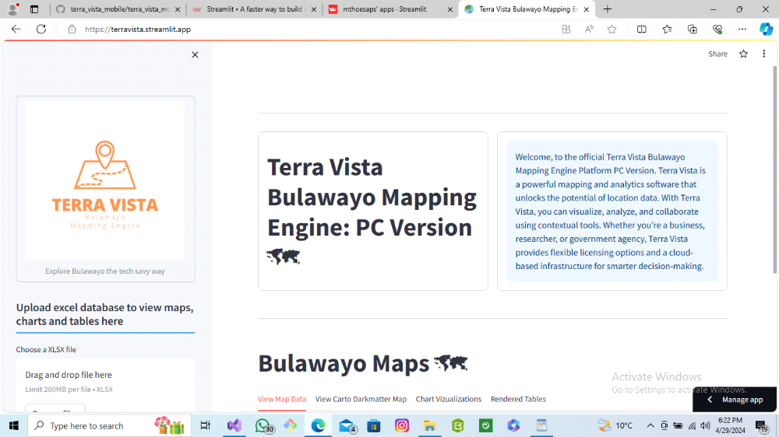
fig 1. displays the home page of the engine for PC version

Terra Vista mapping engine uses geospatial data, global positioning systems (GPS), satellites and satellite imagery as well as custom based research databases in order to properly map out and survey (using remote sensing) the City o f Bulawayo. It is a very powerful tool that can be applied for a variety of purposes in The Built Environment such as policy making and zonation of towns, cities as well as communal lands (by local planning authorities) and to clearly identify hotspot areas that are prime locations for profitable land development (construction projects) and real estate based projects.
The engine is designed by Mthokozisi Thabiso Sapuwa, a final year student at the National University of Science and Technology studying Property Development and Estate Management so you can trust that the engine is developed mainly for the purposes of surveying and mapping Bulawayo.

3. How does it work and how to use it.
Terra Vista is built using python programming and a plethora of other python API’s and libraries to make it fully functional and interactive. The source code of the engine is developed from scratch by Mthoe Saps Construction Technologies meaning each and every aspect of the engine is completely alterable to the desired outcome of the Developer thus we have full control of how the engine functions, how it is optimised and all capabilities and features are monitored by us.
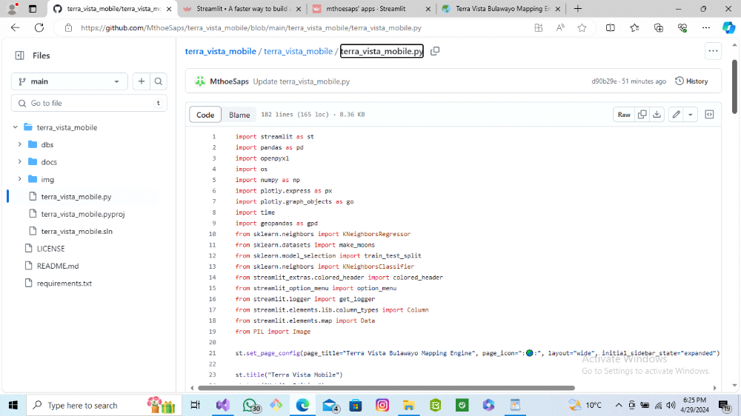
fig 2 above shows a code snippet of the plethora of libraries used to build the engine

The engine is built in a simple to use manner and it already has aleady managed to map over 120 low, medium and high density suburbs of Bulawayo. The engine is designed to work using an SQL database or an Excel file database this means that users if the engine can either send their excel file databases to the developer for uploading or they can have an excel file uploader which can ready the users database and then convert the data to graphically visible data through maps and graphs that the user choses to have uploaded thus the engine is completely dependent on the users data to render the needed diagrams and information to the screen.
As mentiomed the engine comes with over 200 located areas of Bulawayo thus the user will directly have access to this data and the database is also downloadable. Users will have to download this dataset and add their desired information on the rows and reupload the dataset to update the Terra Vista Bulawayo Mapping and Survey Engine in real time. This goes to show the ease of use of the sofware and also the powerful backend design of the app to be able to render these surveys and maps in real time with custom databases that can display and locate the desired users needs.
fig 3 below shows the engine's Bulawayo Open-Stree-Map locating the suburbs of Bulawayo with hover data ability, the information displayed can be changed to the users request by configuring the algorithm to the users needs.
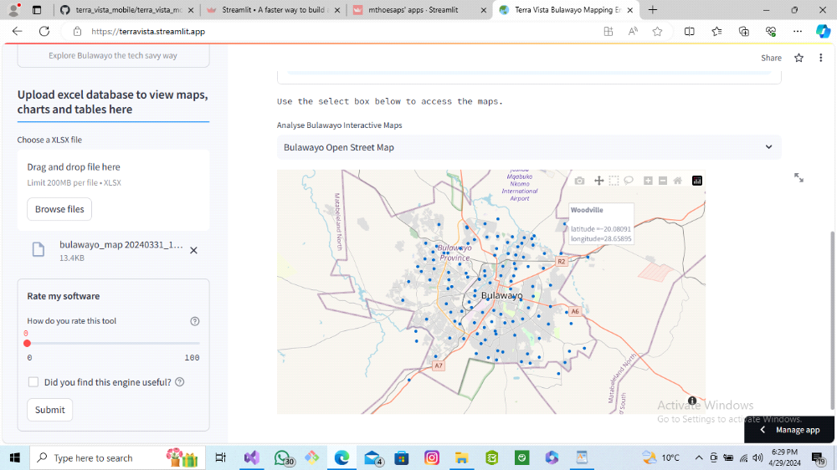

About Terra Vista Cloud Compiting Advances
Terra Vista, a cloud-based mapping and surveying engine is a powerful software solution that leverages cloud computing technologies to provide efficient and scalable mapping and surveying capabilities. It enables users to collect, analyze, and visualize geospatial data in real time, making it an essential tool for various industries such as urban planning, agriculture, logistics, and environmental management.

The engine operates by seamlessly integrating with remote sensing technologies, such as satellite imagery, aerial photography, and LiDAR data, to generate accurate and up-to-date maps and survey data. These data sources are processed and stored in the cloud, allowing users to access and manipulate them from anywhere with an internet connection.
The cloud-based nature of the engine offers several key advantages. Firstly, it eliminates the need for users to invest in expensive hardware, as the processing and storage requirements are handled by the cloud infrastructure. This significantly reduces the upfront costs and allows organizations of all sizes to leverage advanced mapping and surveying capabilities.
Secondly, the engine provides a high level of scalability. With cloud computing resources, users can easily scale up or down their operations based on their specific needs. Whether it’s processing large volumes of data or accommodating a sudden surge in demand, the engine can dynamically allocate computing resources to ensure optimal performance and responsiveness.
Furthermore, a cloud-based mapping and surveying engine promotes collaboration and data sharing. Multiple users can work on the same project simultaneously, accessing and updating the data in real time. This facilitates seamless teamwork, enhances productivity, and eliminates the need for manual data synchronization.

Terra Vista cloud-based mapping and surveying engine revolutionizes the way geospatial data is collected, processed, and analyzed. Its cloud infrastructure, scalability, and collaborative features make it an indispensable tool for organizations seeking efficient, cost-effective, and accurate mapping and surveying solutions. Thus, Terra Vista software mapping engine harnesses the power of cloud computing to deliver cutting-edge mapping and surveying capabilities.
4. What API’s does Terra Vista Bulawayo Mapping Survey Engine use?
Refer to fig 2.
The software is built ontop of a number of high level programming libraries. To mention but a few of the most important ones are the use of Plotly, Streamlit, Pandas as well as Numpy and scikit-learn library. These libraries enables the Terra Vista Bulawayo Mapping Survey Engine algorithm to perform a number of high level activities and abilities such as the ability to combine GIS and Remote Sensing as well as being able to add Machine Learning (ML) and Artificial Intelligence (AI) in order to form more accurate and precise plots using this robust engine.
As much as the libraries used to build the tool are as good as they get in the technovative industry, this does not mean our engine is completely going to dependant on its current libraries and API’s for it functionality but we will continue to update the Mapping Engine and add more features to it as well by exploring other libraries that will definitely improve the functionality and usability of the engine.
This system enables superuseful information for example we will provide the most robust mapping system that enables users to locate super accurate land development sites for precise use and land development allocations. It renders database based information that the users end to the developer or can upload via the Excel file uploader in the engine in order to create robust mapping systems for their preffered land use.

5. Gaps filled by the Terra Vista Bulawayo Mapping Survery Engine that competitors have not fulfilled in the Bulawayo Market:
Refer to the user installation and user guide tutorial for images.
- Developing custom software that can interpret and visualize excel, csv, and other type datasets to graphically usable data.
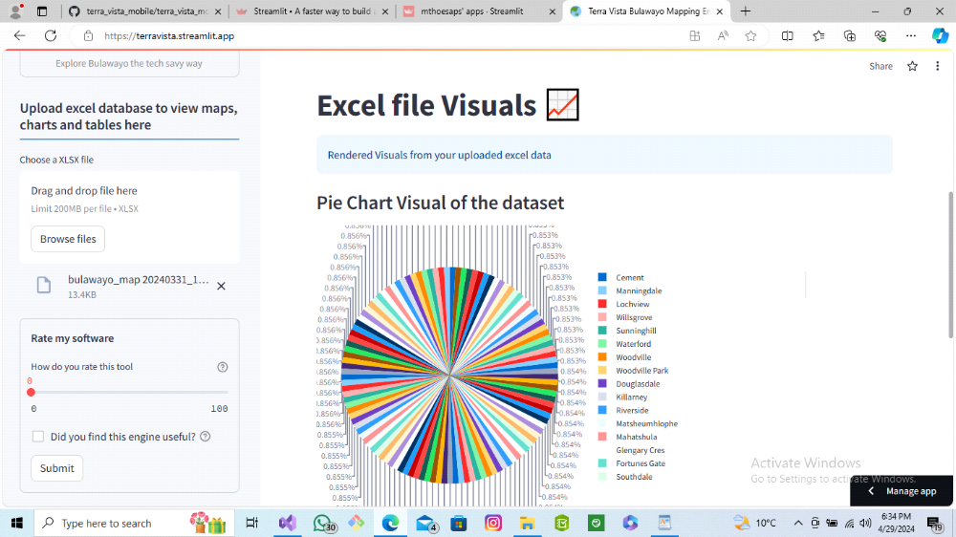
fig 4 above and fig 5 below display the high level visualization ability of the engine. All the data is obtained from and excel file that provides the engine the data and the engine processes and converts the data into usable visuals that are easier to translate.
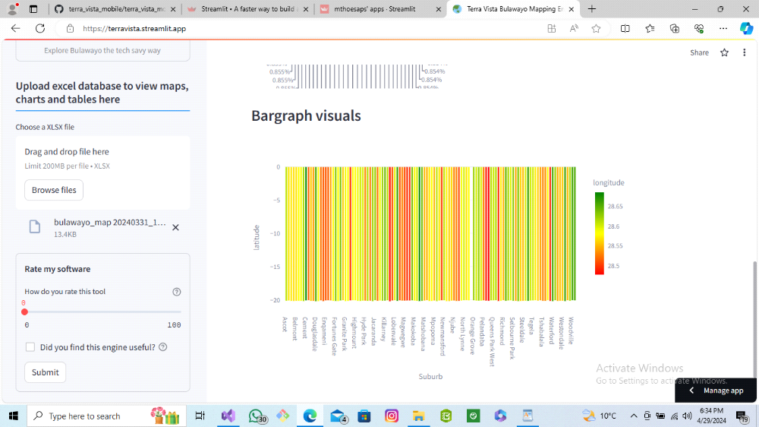
- Terra Vista is a cloud hosted mapping engine, this means that users do not have to install anything thus they just receive the link from the Developer abd they start using the engine as simple as that.
- Developing custom software that meets the exact needs of the client and can be tailored anytime depending on the job requirements meaning software is able to handle large and robust databases and datasets.
- Breaking the barriers of land survey in Zimbabwe, this system is less labor intensive, and less time consuming. The main aim of our project is to be able to accurately draw new maps of Bulawayo (and Zimbabwe over if the project exceeds beta testing) in a short amount of time as well as providing high level technology to Bulawayo based companies and firms. Maps are rendered in less than a minute the moment you upload your data and all visuals wll appear.
6. Release of New Software and Software Updates:
Mthoe Saps Construction Technologies will be constatly hands on with the maintanace of the Terra Vista Bulawayo Mapping Survey Engine. The engines will be carefully optimized and regularly maintained and debugged to always ensure a smooth user experience for our clients/ users. We will also be heavily invested in developing new and exciting software upgrades and adding more plug-ins to the software engine for the benefit of all users and clients so you can rest assured you are in for a new and exciting technological journey as we are already exploring into the unchartered territories of 3D Drone Mapping and Surveying. Terra Vista Bulawayo Mapping and Survey Engine users have the advantage of getting and experiencing first hand technological developments from Mthoe Saps Construction Technologies as a dedicated web app will be designed for this communication as mentioned above.
fig 6 below shows our informatics website, you can visit it anytime to check updates on our projects and upcoming software updates. Url links will be provided to access this site.
- for the desktop version of the informations website use:
https://msconstructiontechinfoweb.streamlit.app/
for the mobile version of the application use:
https://mthosapsconstructiontechnologymobileapp.streamlit.app/

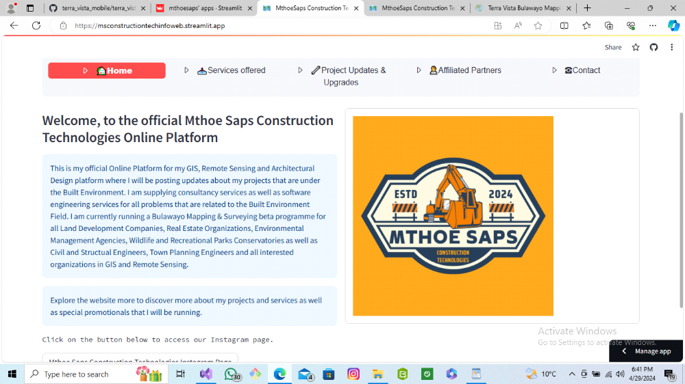

Nb: The number of documentation will constantly be updated depending on the scope and complexity of software capability advancements. At a minimum an installation guide and a user guide will be provided. Additional documents will be created to address specific functionalities, advanced topics, or developer-related documentation.

7. Software packages for beta signed companies:
Clients of the Terra Vista Engine will get the following packages:
(i) A customized Terra Vista Bulawayo Mapping and Survey Engine.
(ii) The engine comes in PC version (compartible with Windows, Mac and Linux based operating systems and Mobile version (compartible with Android and iOS devices).
(iii) Access to the Mthoe Saps Construction Technologies Bulawayo Mapping and Survey to keep up with our one of a kind prototype Mapping and Surveying tool that is currently undergoig beta testing.
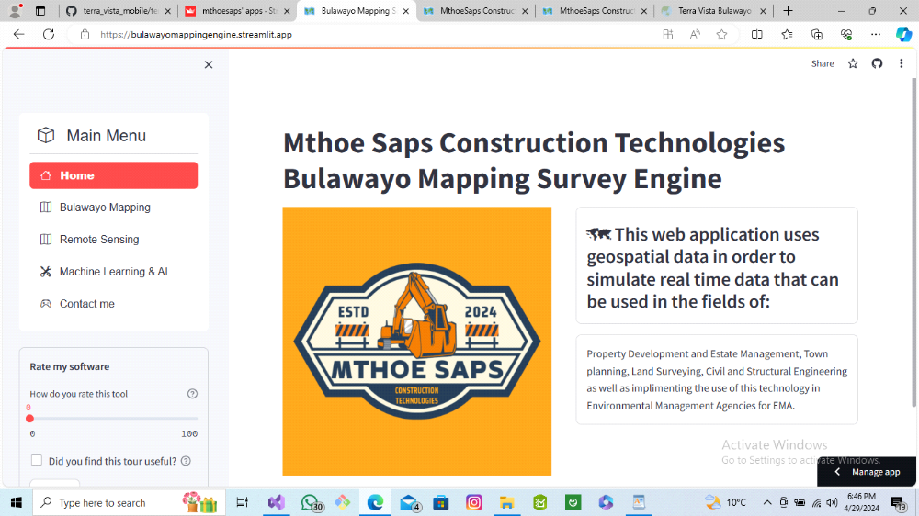
fig 9 above displays out Bulawayo Mapping Engine that is in beta testing, this engine works withbackend development and is currently under research and development to achieve much more advanced remote sensing capabilities.

8. Terra Vista Bulawayo Mapping and Survey Engine pricing scheme:
The engine is being sold for USD $787.97 with a montly debug and running fee of USD $40.00

9. About Developer:
Terra Vista Engine is designed by Mthokozisi Thabis Sapuwa a final year student at the National University of Science and Technology undertaking a undergraduate Bachelor of Science Honors Degree in Property Development and Estate Management. I am a big enthusiast and also an aspiring land developer thus I have invested my time and skill into creating a special tool for the Built Environment that can simulate geospatial data into graphically visible charts, diagrams as well as two dimensional(2D) and three Dimensional (3D) real time maps.
Terra Vista also seeks to introduce drone surveying which is one of the most accurate and most reliable drone mapping and surveying in the technological market. Drone Surveying and Mapping will be added to the engine by 07 January 2025. More documentation will be provided to the Terra Vista users after the official purchase of their first Terra Vista Engine model.

10. Community forums page:
All Terra Vista news and updates will have have one update dedicated social media account on Instagram and will also have its updates news in the Mthoe Saps Construction Technologies informatics website that will be the go to social media page and website for the project updates.

11. Licencing and Services:
The Terra Vista Bulawayo Mapping Survey Engine licencing and services as well as terms of use of the web app are highlighted on the contact, read through the contract clearly to understand the terms of use and licencing.

11.a. Software Specs:
These specs are both for PC and Mobile device users:
Current Software size = 338MB (354 504 231 bytes)
Size on disk = 390MB (409 686 016 bytes)
Contains = 33 651 files and 3 978 Folders

11.b Computer Specs requirements to run Terra Vista Bulawayo Mapping Survey Engine
1. Atleast Quadcore processor machine
2. 4 gig ram and upwards
3. Operating system: Fully optimized to work on Linux, Windows, Apple devices, Android devices
4. Windows version: Microsoft Windows 10 Home (recommended) but can also work on older Microsoft Windows Versions at most Windows 7
5. System model: optimized for x64-based PC
6. Processor: Intel(R) Celeron(R) CPU N3050 @1.60GHz, 1601 Mhz, 2 Cores, 2 logical processors or better
7. Stable WiFi connection

11.c Mobile Specs Required to run Terra Vista Bulawayo Mapping Survey Engine:
1. Atleast 6 gigs of RAM or better
2. Atleast 5 gig free mobile storage
3. Processor: Exynos 1330 5nm or better
4. Mobile phone version: should be version 9 or better for better mobile device experience use
5. Optimized to work on Andorid, Apple and Huawei operating systems

12. Trademarks
The following organizations are accredited for the creation of this tool:
1. Plotly
2. Pandas
3. Numpy
4. Scikit-learn
5. Streamlit
6. Pillow
7. Python
8. GeoPandas
9. Mthoe Saps Construction Technologies
10. Nortveil Incorporated (Pvt) Ltd

